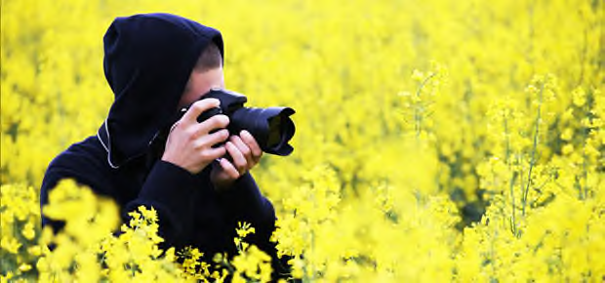
CALLING ALL NATURE PHOTOGRAPHERS!
Submit your photographs for consideration in the 2021
Protectors of Pine Oak Woods
Staten Island Nature & Wildlife Calendar

Protectors of Pine Oak Woods is seeking photographs for the 2021 Staten Island Nature and Wildlife Calendar. From the images submitted by our talented photographers we will again produce a calendar celebrating nature at its best on Staten Island and, in this trying year of COVID-19, assert that life and nature go on. An Ad Hoc Committee consisting of PPOW Board Members and Staten Island Naturalists has been created to select the photographs to be used in the calendar.
Deadline: July 15, 2020
Entry Fee: There is no fee for submissions.
Compensation: Two Calendars if your photograph is used in the calendar.
Notification of accepted artists: August 15, 2020
Please submit digitally – one photograph per each e-mail. The maximum # of submissions per photographer is 8.
Please provide the information about each photo below and save the document as a word file or pdf file. Email a separate form with each entry to: protectors2021@gmail.com
Format: 4 MB minimum
By this submission, I grant to Protectors of Pine Oak Woods the use of my photograph(s) for this project. I authorize Protectors of Pine Oak Woods to use and publish the same in print and/or electronically. Photographs selected for the calendar may also be displayed at exhibitions and will include credit to the photographer. A release agreement will be provided if your work is selected.
Include: Your name______________________________________________________
Location of Photograph__________________________________________________
Date of Photograph (estimate) ____________________________________________
We look forward to celebrating Staten Island’s natural beauty in a Protectors of Pine Oak Woods Staten Island Nature and Wildlife Calendar and thank the many talented photographers for their submissions!

