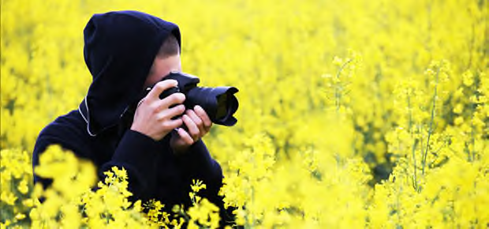
CALLING ALL NATURE PHOTOGRAPHERS!
Submit your photographs for consideration in the 2022
Protectors of Pine Oak Woods
Staten Island Nature & Wildlife Calendar

Photographs will highlight the variety and uniqueness of Staten Island Parks and Natural Areas. Each month will be represented by a photograph of that season and selected based on quality, content and ability to capture the natural beauty of Staten Island with a goal to highlight a park or natural area. An Ad Hoc Committee consisting of PPOW Board Members and Staten Island Naturalists has been created to select the photographs to be used in the calendar.
Deadline: June 16, 2021
Entry Fee: There is no fee for submissions.
Compensation: Two PPOW Calendars only if your photograph is used in the calendar.
Notification of accepted artists: July 30, 2021
Submit each photograph electronically with this completed release (or the information below) – one per email. The maximum # of submissions per photographer is 8.
Format: 4 MB minimum, JPEGS preferred.
Email each entry to: Protectors2022@gmail.com
RELEASE AGREEMENT
Submission of photographs and signature will constitute a release agreement for the use of your photographs in print or electronically. Please do not place your name or logo on the photograph. We will credit the photographer.
Include:
Your Name |  |  | Click or tap here to enter text.
Address |  | Click or tap here to enter text.
Phone Number |  |  |  | Click or tap here to enter text.
E-Mail | Click or tap here to enter text.
Location of Photograph |  |  |  |  | Click or tap here to enter text.
Date of Photograph (estimate) |  |  |  |  |  | Click or tap here to enter text.
We look forward to celebrating Staten Island’s natural beauty in a Protectors of Pine Oak Woods Staten Island Nature and Wildlife Calendar and thank the many talented photographers for their submissions!

